**Report on**

**Implementation of Heat Index of a large region using Deep Learning Techniques**

## In partial fulfillment of the requirements for the award of the degree of

## BACHELOR OF TECHNOLOGY

## In

## COMPUTER SCIENCE AND TECHNOLOGY

By

**NAME: FAIZA ASIM**

**ENROLLMENT NO.: A35705220015**

**SEMESTER: 8**

**Under the Guidance of**

**Ms. Kanika Thakur**

**Amity School of Engineering and Technology**

**AMITY UNIVERSITY JHARKHAND**

**DECLARATION**

I, Faiza Asim , a B.Tech. (CSE) student, hereby declare that the report titled "Implementation of Heat Index of a large region using Deep Learning Techniques", which I submitted to AMITY SCHOOL OF ENGINEERING AND TECHNOLOGY, AMITY UNIVERSITY JHARKHAND in partial fulfilment of the requirement has never been used as the basis for the award of any degree, diploma, or other similar title or recognition.

Except for small extracts needing merely due acknowledgment in academic writing, the researcher attests that permission has been acquired for the use of any copyrighted material contained in the dissertation/project report.

DATE :

NAME OF STUDENT : FAIZA ASIM

SIGNATURE OF STUDENT :

**CERTIFICATE**

On the basis of a declaration signed by FAIZA ASIM, a B.Tech (CSE) student, I hereby certify that the project " Implementation of Heat Index of a large region using Deep Learning Techniques " submitted to AMITY SCHOOL OF ENGINEERING AND TECHNOLOGY is correct. AMITY UNIVERSITY JHARKHAND is a unique contribution based on prior knowledge and a meticulous record of work completed by him under my supervision.

To the best of my knowledge, this analysis has not been given in part or in full for any degree or diploma at this university or anywhere.

DATE:

NAME OF GUIDE: KANIKA THAKUR

GUIDE’S SIGNATURE:

**ACKNOWLEDGEMENT**

I owe a debt of appreciation to AMITY SCHOOL OF ENGINEERING AND TECHNOLOGY, JHARKHAND, and my guide Ms. Kanika Thakur for believing in me and encouraging me to finish my term paper.

I want to express my gratitude to my family and friends for believing in me and supporting me during the full research paper writing procedure.

This has been a fantastic learning experience for me, and I want to thank everyone who helped make this project a success again.

APPROVAL LETTER

**Preliminary Pages**

* Declaration
* Certificate
* Acknowledgement
* Approval Letter

**List of Contents (Main Text)**

1. **Abstract**
2. **Introduction**
3. **Literature Review**
4. **Comparative Study**
5. **Research Methodology**
6. **What is Heat Index?**
7. **Deep Learning Models**
8. **CNN(Convolutional-Neural Network)**
9. **RNN(Recurrent Neural Network)**
10. **Seasonality in Meteorology**
11. **Time Series Prediction**
12. **Stationarity and Seasonality**
13. **Types of Models**
14. **Difference between Traditional and Machine Learning Models**
15. **ARIMA MODEL**
16. **AR Models**
17. **ARIMA NOTATION**
18. **DICKEY-FULLER METHOD**
19. **HEAT INDEX**
20. **CODE FOR CHECKING THE CONTINUITY OF THE DATA**
21. **LSTM MODEL**
22. **CODE FOR PREDICTING HEAT INDEX**
23. **Key Points Conclusion**
24. **Reference**
25. **ABSTRACT**

The implementation of deep learning techniques for calculating the Heat Index of a large region represents a significant advancement in meteorological research and weather prediction. The Heat Index, also known as the apparent temperature, is a critical metric for assessing heat-related risks and thermal comfort in diverse geographical areas. Traditional methods of calculating the Heat Index often fall short in capturing the complex interactions between temperature and humidity variations across expansive regions, leading to inaccuracies in predictions.

Deep learning, a subset of artificial intelligence, offers a data-driven approach to analyzing historical temperature and humidity data to accurately calculate the Heat Index. By training neural networks to recognize patterns and relationships within the data, deep learning models can provide more precise and reliable Heat Index calculations, especially in regions with diverse microclimates.

This abstract provides an overview of the importance of accurately calculating the Heat Index in large regions, the limitations of traditional methods, and the potential of deep learning techniques in revolutionizing Heat Index prediction. By leveraging the power of deep learning, meteorologists and researchers can enhance their understanding of thermal comfort, improve the accuracy of heat-related predictions, and better prepare for the impacts of extreme heat events in a changing climate landscape.

1. **INTRODUCTION**

The heat index, also known as the apparent temperature, is a measure used to quantify the perceived discomfort experienced by the human body due to a combination of air temperature and relative humidity. It provides valuable insight into how hot weather conditions feel to individuals, taking into account the body's ability to regulate heat through sweating and evaporation. The concept of the heat index is particularly important in understanding the potential health risks associated with exposure to high temperatures, especially in regions prone to heatwaves or extreme weather events.

At its core, the heat index reflects the impact of humidity on the body's ability to cool down efficiently. When the air is humid, sweat evaporates more slowly, leading to a reduced cooling effect on the skin. As a result, even at relatively moderate temperatures, high humidity levels can contribute to feelings of discomfort and increased risk of heat-related illnesses such as heat exhaustion or heatstroke.

The calculation of the heat index involves complex physiological and meteorological principles. One commonly used formula to calculate the heat index is the Steadman Heat Index Equation, developed by American meteorologist George Steadman in the 1970s. This equation takes into account both air temperature and relative humidity to estimate the apparent temperature felt by the human body.

It plays a crucial role in assessing the thermal comfort and potential health risks associated with high temperatures in a given region. As global temperatures continue to rise due to climate change, accurately calculating the Heat Index becomes increasingly important, especially in large regions where diverse climatic conditions can exist.

Traditional methods of calculating the Heat Index rely on mathematical formulas that consider the air temperature and relative humidity. While these methods have been used for decades, they often struggle to capture the complex interactions between temperature and humidity variations across vast geographical areas. This limitation can lead to inaccuracies in Heat Index predictions, particularly in regions with diverse microclimates.

In recent years, the advent of deep learning techniques has revolutionized the field of meteorology by offering a more sophisticated and data-driven approach to weather prediction and climate modeling. Deep learning, a subset of artificial intelligence, involves training neural networks to learn patterns and relationships within data, enabling them to make accurate predictions and classifications.

By implementing deep learning techniques for calculating the Heat Index of a large region, meteorologists and researchers can leverage the power of neural networks to analyze vast amounts of historical temperature and humidity data. These deep learning models can capture intricate patterns and non-linear relationships that traditional methods may overlook, leading to more precise and reliable Heat Index calculations.

The use of deep learning for Heat Index calculation offers several advantages, including improved accuracy, scalability, and adaptability to diverse environmental conditions. Deep learning models can adapt to changing climatic patterns and provide real-time updates on Heat Index values, allowing stakeholders to make informed decisions to protect public health and safety.

In the following sections, we will delve deeper into the process of implementing deep learning for Heat Index calculation, exploring data collection and preprocessing, model selection, training procedures, as well as the challenges and future prospects associated with this innovative approach. By harnessing the potential of deep learning in meteorology, we can enhance our understanding of thermal comfort in large regions and better prepare for the challenges posed by extreme heat events in a changing climate landscape.

1. **LITERATURE REVIEW**

The implementation of deep learning techniques for calculating the Heat Index of a large region has garnered significant attention in the field of meteorology and climate science. This literature review aims to provide an overview of existing studies, research findings, and advancements related to the use of deep learning in Heat Index prediction.

**Importance of Heat Index Calculation**

Accurately calculating the Heat Index is crucial for assessing heat-related risks, protecting public health, and informing decision-making in various sectors. Traditional methods of calculating the Heat Index, such as the Steadman formula, have limitations in capturing the complex interactions between temperature and humidity variations, especially in large and diverse regions.

**Deep Learning in Meteorology**

Deep learning, a subset of artificial intelligence, has shown promising results in various meteorological applications, including weather forecasting, climate modeling, and now, Heat Index prediction. By training neural networks to analyze historical temperature and humidity data, deep learning models can learn complex patterns and relationships to provide more accurate and reliable Heat Index calculations.

**Studies on Deep Learning for Heat Index Prediction**

Recent studies have demonstrated the effectiveness of deep learning techniques in improving the accuracy of Heat Index predictions. Researchers have explored different deep learning architectures, such as convolutional neural networks (CNNs) and recurrent neural networks (RNNs), to capture spatial and temporal dependencies in temperature and humidity data. These studies have highlighted the potential of deep learning models to outperform traditional methods in Heat Index calculation.

**Data Collection and Preprocessing**

One of the key challenges in implementing deep learning for Heat Index prediction is the collection and preprocessing of large-scale meteorological data. Researchers have developed methodologies to gather historical temperature and humidity data from weather stations, satellites, and other sources, and preprocess the data to ensure its quality and consistency for training deep learning models.

**Advantages and Limitations**

The use of deep learning for Heat Index calculation offers several advantages, including improved accuracy, scalability, and adaptability to diverse environmental conditions. However, challenges such as data availability, computational resources, and model interpretability remain areas of concern that require further research and development.

1. **COMPARATIVE STUDY**

In the realm of meteorology and climate science, the implementation of deep learning techniques for calculating the Heat Index of a large region has sparked a comparative analysis of traditional methods and innovative approaches. This comparative study aims to evaluate the effectiveness, advantages, and limitations of using deep learning techniques in Heat Index prediction compared to traditional calculation methods.

**Traditional Methods of Heat Index Calculation**

Traditional methods of calculating the Heat Index, such as the Steadman formula, rely on mathematical equations that consider air temperature and relative humidity to estimate the perceived temperature. While these methods have been widely used for decades, they often struggle to capture the complex interactions between temperature and humidity variations across diverse regions, leading to inaccuracies in Heat Index predictions.

**Deep Learning Techniques for Heat Index Prediction**

In contrast, deep learning techniques offer a data-driven approach to analyzing historical temperature and humidity data to calculate the Heat Index. By training neural networks to learn patterns and relationships within the data, deep learning models can provide more accurate and reliable Heat Index predictions, especially in large regions with varying climatic conditions.

**Comparative Analysis**

**Accuracy and Precision**

One of the key advantages of using deep learning for Heat Index prediction is the improved accuracy and precision it offers compared to traditional methods. Deep learning models can capture intricate patterns and non-linear relationships in the data, leading to more reliable Heat Index calculations, especially in regions with complex microclimates.

**Scalability and Adaptability**

Deep learning models are highly scalable and adaptable to diverse environmental conditions, making them ideal for calculating the Heat Index of large regions. Traditional methods may struggle to scale effectively or adapt to changing climatic patterns, limiting their utility in dynamic and expansive geographical areas.

**Data Availability and Quality**

A critical aspect of the comparative analysis is the availability and quality of data required for Heat Index prediction. Deep learning models rely on large volumes of historical temperature and humidity data, which may pose challenges in data collection and preprocessing. Traditional methods, while less data-intensive, may lack the granularity and accuracy provided by deep learning approaches.

**Computational Resources**

Another factor to consider is the computational resources required for implementing deep learning models for Heat Index prediction. Training neural networks and optimizing model performance can be computationally intensive, requiring access to high-performance computing infrastructure. Traditional methods, on the other hand, maybe more computationally efficient but at the cost of accuracy and flexibility.

As the field of meteorology continues to evolve, future research directions can focus on integrating traditional methods with deep learning techniques to leverage the strengths of both approaches. Collaborative efforts between meteorologists, data scientists, and policymakers can drive innovation in Heat Index prediction and enhance our ability to address the challenges posed by extreme heat events in large regions.

In conclusion, this comparative study highlights the potential of deep learning techniques in revolutionizing Heat Index prediction for large regions and underscores the need for further research to optimize the integration of traditional methods and innovative approaches. By critically evaluating the advantages and limitations of each approach, researchers can advance the field of meteorology and improve our understanding of thermal comfort in a changing climate landscape.

* 1. **Future Research Directions**

Future research in this field can focus on enhancing the performance of deep learning models for Heat Index prediction, exploring ensemble learning techniques, incorporating additional meteorological variables, and integrating real-time data sources for more dynamic predictions. Collaborations between meteorologists, data scientists, and policymakers can drive innovation in leveraging deep learning for Heat Index calculation and improving resilience to extreme heat events.

In conclusion, the literature reviewed underscores the potential of deep learning techniques in revolutionizing Heat Index prediction for large regions. By building on existing research findings and addressing key challenges, researchers can advance the field of meteorology and enhance our ability to mitigate the impacts of extreme heat events in a changing climate landscape.

1. **RESEARCH METHODOLOGY**

Conducting research on the implementation of deep learning techniques for calculating the Heat Index of a large region requires a systematic and structured approach to ensure the validity and reliability of the findings. This research methodology outlines the steps and procedures involved in investigating the application of deep learning in Heat Index prediction.

**Research Design**

The research design for studying the implementation of deep learning techniques for Heat Index calculation will likely involve a combination of quantitative and qualitative methods. Quantitative analysis will be used to evaluate the performance and accuracy of deep learning models in predicting the Heat Index, while qualitative analysis may involve assessing the interpretability and usability of the models.

**Data Collection**

The first step in the research methodology is data collection, which involves gathering historical temperature and humidity data from various sources within the large region of interest. Data may be obtained from weather stations, satellites, meteorological databases, and other sources to ensure a comprehensive dataset for training and testing deep learning models.

**Data Preprocessing**

Once the data is collected, preprocessing steps are essential to clean, normalize, and prepare the data for training the deep learning models. Data preprocessing may involve handling missing values, removing outliers, scaling the data, and splitting it into training and validation sets to ensure the quality and integrity of the dataset.

**Model Selection**

Choosing the right deep learning model is a critical step in the research methodology. Depending on the nature of the data and the complexity of the relationships to be captured, researchers may opt for convolutional neural networks (CNNs), recurrent neural networks (RNNs), or other architectures suitable for Heat Index prediction. The model selection process may involve experimenting with different architectures and hyperparameters to optimize performance.

**Training and Evaluation**

Once the deep learning model is selected, it is trained using the preprocessed data to learn the patterns and relationships necessary for Heat Index prediction. The model is evaluated using validation data to assess its performance in terms of accuracy, precision, and generalization to unseen data. Researchers may employ metrics such as mean squared error, root mean squared error, or correlation coefficients to evaluate model performance.

**Interpretation and Analysis**

After training and evaluating the deep learning model, researchers will interpret the results and analyze the findings to draw conclusions about the effectiveness of using deep learning for Heat Index calculation in a large region. This analysis may involve comparing the model's predictions with actual Heat Index values, identifying patterns and trends in the data, and assessing the model's strengths and limitations.

The research methodology may also include a discussion of future research directions and potential areas for improvement in implementing deep learning techniques for Heat Index prediction. Suggestions for enhancing model performance, integrating additional meteorological variables, and addressing computational challenges can guide future research efforts in this field.

In conclusion, a robust research methodology is essential for investigating the implementation of deep learning techniques for calculating the Heat Index of a large region. By following a structured approach to data collection, preprocessing, model selection, training, and analysis, researchers can advance our understanding of thermal comfort in diverse regions and contribute to the development of innovative solutions for mitigating the impacts of extreme heat events.

1. **DEEP LEARNING**

Deep learning is a subset of artificial intelligence (AI) that mimics the workings of the human brain in processing data and creating patterns for use in decision-making. It involves training artificial neural networks with multiple layers (hence the term "deep") to learn and extract features from large amounts of data.

At the core of deep learning are neural networks, which are computational models inspired by the structure and function of the human brain. These networks consist of interconnected nodes, or neurons, organized in layers. Each layer processes the input data and passes the information to the next layer, allowing the network to learn complex patterns and relationships within the data.

Deep learning algorithms use a process called backpropagation to adjust the weights of the connections between neurons during training. By iteratively feeding the network with input data and comparing the output with the expected result, the model learns to make accurate predictions and classifications based on the patterns it has identified.

Deep learning has shown remarkable success in various fields, including image and speech recognition, natural language processing, and medical diagnosis. In meteorology, deep learning techniques are increasingly being used to analyze weather data, predict climate patterns, and now, calculate metrics such as the Heat Index in large regions.

One of the key advantages of deep learning is its ability to automatically discover and learn features from the data, eliminating the need for manual feature engineering. This makes deep learning models highly adaptable to different types of data and tasks, allowing them to excel in complex and unstructured datasets.

In the context of calculating the Heat Index of a large region, deep learning offers a data-driven approach to analyzing historical temperature and humidity data. By training deep learning models with vast amounts of meteorological data, researchers can leverage the power of neural networks to capture intricate patterns and relationships, leading to more accurate and reliable Heat Index predictions.

Overall, deep learning represents a powerful tool for processing and analyzing large datasets, making complex predictions, and driving advancements in various fields, including meteorology. By harnessing the capabilities of deep learning, researchers can enhance their understanding of complex phenomena and develop innovative solutions to address real-world challenges.

1. **HEAT INDEX**

Heat Index, also known as the apparent temperature, is a measure of how hot it feels when relative humidity is taken into account alongside the actual air temperature. It provides an indication of the perceived temperature by the human body, considering the combined effects of heat and humidity on comfort levels.

The Heat Index is particularly important in assessing the potential health risks associated with high temperatures, as it reflects the body's ability to cool itself through sweating and evaporation. High levels of humidity can hinder the body's natural cooling mechanisms, making it feel hotter than the actual air temperature.

The formula for calculating the Heat Index takes into consideration both the air temperature and the relative humidity. As humidity levels increase, the Heat Index also rises, indicating an increased risk of heat-related illnesses such as heat exhaustion and heatstroke.

In regions with high humidity levels, the Heat Index can significantly exceed the actual temperature, leading to dangerous heat conditions. Meteorologists use the Heat Index to issue heat advisories and warnings to alert the public about the potential risks of prolonged exposure to high temperatures and humidity.

By understanding and monitoring the Heat Index, individuals can take appropriate precautions to stay safe during periods of extreme heat, such as staying hydrated, seeking shade, and avoiding strenuous activities during the hottest parts of the day. Public health officials and policymakers also use the Heat Index to implement heat mitigation strategies and protect vulnerable populations from heat-related health impacts.

In summary, the Heat Index is a valuable metric for assessing thermal comfort, evaluating heat-related risks, and guiding decision-making during periods of high temperatures and humidity. By considering both the air temperature and relative humidity, the Heat Index provides a more comprehensive understanding of how weather conditions can impact human health and well-being.

1. **DEEP LEARNING MODELS**

Deep learning models are neural network architectures designed to learn complex patterns and relationships within data to make predictions, classifications, or generate insights. These models consist of multiple layers of interconnected neurons that process input data and extract features through a process of training and optimization. Here are some commonly used deep learning models in various applications, including meteorology and climate science:

* 1. **Convolutional Neural Networks (CNNs)**

**Description**: CNNs are widely used for image recognition and computer vision tasks. They consist of convolutional layers that apply filters to extract spatial hierarchies of features from input data.

**Application in Meteorology:** CNNs can be applied to analyze satellite images, weather radar data, and other visual meteorological data for tasks such as cloud detection, precipitation estimation, and weather pattern recognition.

* 1. **Recurrent Neural Networks (RNNs)**

**Description**: RNNs are designed to handle sequential data by maintaining a memory of past inputs. They are well-suited for tasks involving time series data or sequences.

**Application in Meteorology**: RNNs can be used for weather forecasting, climate modeling, and analyzing temporal patterns in meteorological data, such as temperature trends and precipitation levels.

* 1. **Long Short-Term Memory Networks (LSTMs)**

**Description:** LSTMs are a type of RNN that can capture long-term dependencies in sequential data. They are equipped with memory cells that can retain information over extended time periods.

**Application in Meteorology:** LSTMs are effective for modeling complex temporal relationships in meteorological data, such as capturing seasonal patterns, climate trends, and extreme weather events.

* 1. **Generative Adversarial Networks (GANs)**

**Description:** GANs consist of two neural networks, a generator, and a discriminator, that are trained in an adversarial manner. GANs are used for generating synthetic data that closely resembles real data distributions.

**Application in Meteorology:** GANs can be utilized to generate synthetic weather data for training deep learning models, augmenting limited datasets, and simulating climate scenarios for research purposes.

* 1. **Autoencoders**

**Description**: Autoencoders are neural networks designed to learn efficient representations of input data by compressing and reconstructing it. They consist of an encoder that compresses the data and a decoder that reconstructs the original input.

**Application in Meteorology**: Autoencoders can be used for dimensionality reduction of meteorological data, anomaly detection in weather patterns, and feature extraction for downstream analysis tasks.

* 1. **Transformer Models**

**Description**: Transformer models are attention-based neural networks that excel in capturing long-range dependencies in sequential data. They have been widely used for natural language processing tasks.

**Application in Meteorology**: Transformer models can be adapted for processing textual meteorological data, such as weather reports, climate research papers, and meteorological forecasts.

These deep learning models represent a diverse set of architectures that can be tailored to specific tasks and datasets in meteorology and climate science. By leveraging the capabilities of these models, researchers can enhance their understanding of complex meteorological phenomena, improve weather predictions, and develop innovative solutions for addressing climate-related challenges.

1. **CNN(Convolutional-Neural Network)**

Convolutional Neural Networks (CNNs) are a class of deep learning models that have revolutionized the field of computer vision and image processing. CNNs are specifically designed to extract features from visual data through the application of convolutional layers, pooling layers, and fully connected layers. Here is an overview of CNNs and their applications in various domains, including meteorology:

* 1. **Architecture :**

- **Convolutional Layers:** These layers apply filters (kernels) to the input data to extract features such as edges, textures, and patterns.

- **Pooling Layers**: Pooling layers downsample the feature maps generated by convolutional layers to reduce computational complexity and extract dominant features.

- Fully Connected Layers: These layers connect every neuron in one layer to every neuron in the next layer, enabling the network to make predictions based on the extracted features.

* 1. **Applications** :

- **Image Analysis:** CNNs can be used to analyze satellite images, weather radar data, and other visual meteorological data for tasks such as cloud detection, precipitation estimation, and weather pattern recognition.

- **Feature Extraction:** CNNs excel at extracting spatial features from meteorological images, enabling researchers to identify complex patterns and relationships in weather data.

- Weather Forecasting: By processing meteorological images and data with CNNs, researchers can improve the accuracy of weather forecasting models and predict climate trends more effectively.

* 1. **Advantages :**

- **Feature Hierarchies**: CNNs automatically learn hierarchical representations of features from data, capturing both low-level and high-level patterns.

- **Translation Invariance**: CNNs are robust to variations in the position and orientation of features in images, making them suitable for analyzing spatial data.

- **Scalability**: CNNs can scale to process large volumes of image data efficiently, making them ideal for analyzing vast amounts of meteorological imagery.

* 1. **Challenges and Considerations:**

- **Data Quality**: CNN performance is highly dependent on the quality and diversity of the training data, requiring clean and representative datasets for optimal results.

- **Model Complexity**: Designing and training complex CNN architectures can be computationally intensive and may require access to high-performance computing resources.

- **Interpretability**: Understanding how CNNs make predictions and interpreting the learned features can be challenging, especially in complex meteorological datasets.

Convolutional Neural Networks offer a powerful tool for analyzing visual meteorological data, extracting meaningful features, and improving weather prediction models. By leveraging the capabilities of CNNs, researchers can enhance their understanding of meteorological phenomena, advance climate research, and develop innovative solutions for addressing weather-related challenges.

1. **RNN(Recurrent Neural Network)**

Recurrent Neural Networks (RNNs) are a class of deep learning models designed to handle sequential data by maintaining a memory of past inputs. RNNs are well-suited for tasks that involve time series data, natural language processing, and sequential pattern recognition. Here is an overview of RNNs and their applications in various domains, including meteorology:

* 1. **The architecture of RNNs**:

- **Recurrent Connections**: RNNs have connections that form loops, allowing information to persist and be passed from one time step to the next.

- **Hidden State**: RNNs maintain a hidden state that captures information about the sequence of inputs seen so far.

**- Long Short-Term Memory (LSTM**): Variants of RNNs, such as LSTMs, address the vanishing gradient problem and can capture long-term dependencies in sequential data.

* 1. **Applications** :

- **Weather Forecasting**: RNNs can be used to model and predict weather patterns based on historical meteorological data, such as temperature, humidity, and wind speed.

- **Climate Modeling**: RNNs are employed to analyze climate trends, predict long-term climate patterns, and assess the impact of climate change on weather systems.

- **Temporal Pattern Recognition**: RNNs can identify temporal patterns in meteorological data, such as seasonal trends, extreme weather events, and cyclical phenomena like El Niño.

* 1. **Advantages** :

- **Sequential Modeling**: RNNs excel at capturing sequential dependencies in data, making them suitable for time series analysis and sequential pattern recognition.

- **Memory Retention:** RNNs can retain information over multiple time steps, allowing them to learn from past inputs and make predictions based on context.

- **Flexibility:** RNNs can handle inputs of varying lengths and adapt to different temporal structures in data, providing flexibility in modeling sequential data.

* 1. **Challenges and Considerations:**

- **Vanishing Gradient**: RNNs are prone to the vanishing gradient problem, where gradients diminish over long sequences, affecting the model's ability to learn long-term dependencies.

- **Training Instability**: Training RNNs can be challenging due to issues like exploding gradients, which can destabilize the learning process.

- **Model Interpretability**: Understanding how RNNs make predictions and interpreting the learned representations can be complex, especially in the context of meteorological data.

Recurrent Neural Networks offer a powerful framework for analyzing sequential meteorological data, capturing temporal dependencies, and making predictions based on historical patterns. By leveraging the capabilities of RNNs, researchers can enhance weather forecasting models, improve climate predictions, and gain insights into the dynamics of meteorological systems.

1. **TIME SERIES PREDICTION**

Time Series is defined as a series of data points indexed in time order.

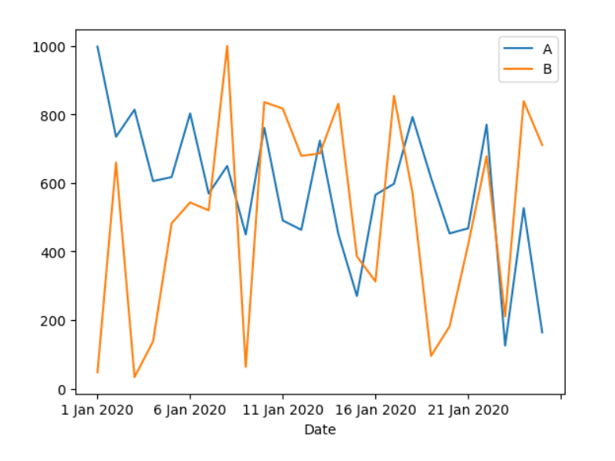

Many traditional models require the time series to be stationary.

**Stationary-** Statistical properties such as mean, variance, and serial correlation are constant over time.

Stationarity makes analysis more straightforward but modern approaches make it possible to work with the data without pre-processing for stationary.

* 1. **Stationarity?**
* Statistical properties more or less, same over time.
* Properties-

1. Constant Mean
2. Constant Variance
3. No seasonality
   1. **Seasonality?**

* Repeating trends/patterns over time.
* Log proportions to smooth exponential curves

( Log exp (x)= x )

* Seasonal differencing

( Y(t) – Y( t – N ) )

1. **Seasonality in Meteorology**

Seasonality in meteorology refers to the recurring patterns and variations in weather conditions that follow a regular cycle over the course of a year. These seasonal changes are influenced by factors such as the tilt of the Earth's axis, the Earth's orbit around the sun, and the distribution of solar radiation across different latitudes. Seasonality plays a significant role in shaping climate patterns, temperature fluctuations, precipitation levels, and weather phenomena throughout the year.

* 1. **Key Aspects of Seasonality**:

- **Temperature Fluctuations**: Seasonality manifests as changes in temperature, with distinct patterns of warming and cooling observed during different seasons. In the Northern Hemisphere, for example, summer typically experiences warmer temperatures due to increased solar radiation, while winter sees colder temperatures as sunlight is less direct.

- **Precipitation Patterns**: Seasonal variations in precipitation levels are common, with some regions experiencing wet seasons and dry seasons. These patterns are influenced by factors such as the movement of air masses, the presence of atmospheric fronts, and the proximity to bodies of water.

- **Daylight Hours**: Seasonality affects the duration of daylight hours, with longer days and shorter nights during the summer months and vice versa in winter. This variation in daylight hours influences factors such as plant growth, energy consumption, and human activities.

- **Natural Phenomena**: Seasonality influences natural phenomena such as the blooming of flowers in spring, the migration of animals in fall, and the formation of ice and snow in winter. These seasonal events are essential for ecosystem dynamics and biodiversity.

* 1. **Impacts of Seasonality**:

- **Agriculture**: Seasonality plays a crucial role in agricultural practices, influencing planting and harvesting schedules, crop yields, and the availability of fresh produce. Farmers rely on seasonal forecasts to plan their activities and mitigate risks associated with weather variability.

- **Tourism**: Seasonality affects tourism patterns, with travelers often choosing destinations based on the prevailing weather conditions. Beach resorts may experience peak seasons during the summer months, while ski resorts thrive in winter.

- **Energy Demand**: Seasonal variations in temperature impact energy demand for heating and cooling purposes. Energy providers must anticipate fluctuations in energy consumption and adjust supply accordingly to meet the needs of consumers.

- **Health and Well-being**: Seasonality can affect human health and well-being, with changes in weather conditions influencing factors such as respiratory illnesses, seasonal allergies, and mental health. Extreme weather events associated with certain seasons can pose risks to public safety.

* 1. **Mitigation Strategies**:

**- Climate Modeling:** Meteorologists use climate models to predict seasonal patterns and trends, providing valuable insights for planning and decision-making.

- **Seasonal Forecasts**: Seasonal forecasts help stakeholders prepare for weather-related risks and opportunities, enabling proactive measures to be taken in response to anticipated conditions.

**- Adaptation Measures**: Communities and industries implement adaptation measures to cope with seasonal variations, such as water management strategies, infrastructure upgrades, and disaster preparedness plans.

Seasonality is a fundamental aspect of meteorology that influences weather patterns, climate dynamics, and various aspects of human life. By understanding and adapting to seasonal variations, individuals, communities, and organizations can better navigate the challenges and opportunities presented by changing weather conditions throughout the year.

1. **TYPES OF MODEL**
   1. **Difference between Traditional and Machine Learning Models**

|  |  |
| --- | --- |
| **Traditional** | **Machine Learning** |
| * Recursive. | * Direct. |
| * Makes predictions for tomorrow, the day after tomorrow, and so on……. | * Makes predictions directly depending on the horizon. |
| * Tough to get right. | * Easy to get right. |
| * Easy to extend. | * Tough to extend. |
| * Can’t add time-varying features. | * Can add time-varying variables as features. |

1. **ARIMA MODEL**

**(Box-Jenkins Method)**

Auto-Regression Integrated Moving Average

A class of statistical model for analyzing and force-costing time series data.

The latter condition means that its auto-correlation remains constant over time.

A random variable of this form can be viewed as a combination of signal and noise.

**AR -** Auto-Regression – uses a dependent relationship between an observation and some numbers of lagged observations.

P= lag order

I - Integrated – The use of differencing of raw observations.

d= Degree of differencing

**MA -** Moving Average- Uses the dependency between observation and residual errors from a moving average model applied to lagged observations.

q = Order of moving average

**Assumptions of the ARIMA Model?**

* Stationarity
* Uncorrelated random error
* No outliers
  1. **ITERATIVE APPROACH**
  2. **Identification-**

Identify the parameters of an ARMA model for the data.

Access whether the time series is stationary, and if not, how many differences are required to make it stationary.

**Data Collection**:

Estimate the time required to collect meteorological data from various sources covering the large geographical region.

Consider factors such as data availability, accessibility, and quality assurance procedures.

Account for any delays or challenges in acquiring the necessary data.

**Model Training**:

Estimate the time needed to develop and train the deep learning model using the collected data.

Consider the complexity of the model architecture, size of the dataset, and computational resources available.

Account for time spent on data preprocessing, feature engineering, and hyperparameter tuning.

**Evaluation**:

Allocate time for evaluating the trained model's performance using appropriate metrics and validation procedures.

Consider the time required for cross-validation, holdout validation, or other validation techniques to assess the model's generalization ability.

Account for any additional analysis or visualization tasks to interpret the evaluation results effectively.

**Refinement**:

Estimate the time needed to analyze the model's performance, identify areas for improvement, and implement refinements.

Consider feedback loops from the evaluation stage and incorporate necessary changes to the model architecture or training process.

Account for multiple iterations of refinement based on validation results and stakeholder feedback.

**Feedback Loops and Validation Procedures:**

Allocate time for incorporating feedback from stakeholders, domain experts, and validation procedures into the iterative process.

Consider the time required for communication, collaboration, and coordination among team members involved in the project.

Account for any delays or revisions resulting from feedback and validation outcomes.

1. **AR Models**

Autoregressive Moving Average (ARMA) models are widely used for time series forecasting. They combine two fundamental approaches: autoregression (AR) and moving averages (MA). The ARMA model is suitable for stationary time series data, meaning the statistical properties such as mean, and variance are constant over time.

**Regression –** Used to predict the continuous value of an item based on certain parameters.

**Auto –** Uses its post values to predict future values.

Yt  = C1Yt-1 + C2 🡪 AR(1) : 1ST Order AR

Yt  = C1  + C2YT-1 + C3YT-2 🡪 AR(2) : 2ND Order AR

**Moving Average (MA)**

Models that predict future values of a time series using past errors.

AR : Yt  = C1Yt-1 + C2 + Et 🡪 AR(1)

MA : Yt = μ + C1Et-1 + Et 🡪 MA(1)

1. **ARIMA NOTATION**

ARIMA notation is used to describe the structure of an ARIMA (AutoRegressive Integrated Moving Average) model in time series analysis. ARIMA models are popular for forecasting and understanding time series data. The notation ARIMA(p, d, q) is used to specify the model, where:

- p: The number of lag observations included in the model (the number of autoregressive terms). This is the order of the AR (AutoRegressive) part.

- d: The number of times that the raw observations are differenced to make the time series stationary. This is the order of differencing.

- q: The size of the moving average window (the number of lagged forecast errors in the prediction equation). This is the order of the MA (Moving Average) part.

**Breakdown**

**AR (AutoRegressive) part (p):**

- This component uses the relationship between an observation and a number of lagged observations (i.e., previous values in the time series).

- The AR(p) model can be written as:

\[

X_t = c + \phi_1 X_{t-1} + \phi_2 X_{t-2} + \dots + \phi_p X_{t-p} + \epsilon_t

\]

where \( X_t \) is the value at time \( t \), \( c \) is a constant, \( \phi_1, \phi_2, \ldots, \phi_p \) are parameters, and \( \epsilon_t \) is white noise.

**I (Integrated) part (d):**

- This component involves differencing the data to make it stationary, which means the mean and variance are constant over time.

- If \( d = 1 \), it means we take the first difference of the data (i.e., subtracting the previous observation from the current observation).

- If \( d = 2 \), it means taking the second difference (i.e., differencing the first differences).

**MA (Moving Average) part (q):**

- This component uses the dependency between an observation and a residual error from a moving average model applied to lagged observations.

- The MA(q) model can be written as:

\[

X_t = c + \epsilon_t + \theta_1 \epsilon_{t-1} + \theta_2 \epsilon_{t-2} + \dots + \theta_q \epsilon_{t-q}

\]

where \( \theta_1, \theta_2, \ldots, \theta_q \) are parameters and \( \epsilon_t \) is white noise.

Ex.

ARIMA(2,1,1) model has:

- p = 2: Two lagged values are used in the model.

- d = 1: The time series is differenced once to make it stationary.

- q = 1: One lagged forecast error is used in the model.

The model can be written as:

\[

(1 - \phi_1 B - \phi_2 B^2)(1 - B)X_t = (1 + \theta_1 B)\epsilon_t

\]

where \( B \) is the backshift operator (i.e., \( B X_t = X_{t-1} \)).

In practice, determining the appropriate values for \( p \), \( d \), and \( q \) often involves analyzing the autocorrelation function (ACF) and partial autocorrelation function (PACF) of the time series, along with model selection criteria such as the Akaike Information Criterion (AIC) or the Bayesian Information Criterion (BIC).

1. **ARIMA MODEL**

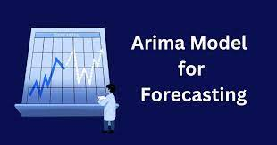

Autoregressive Integrated Moving Average (ARIMA) models are a class of statistical models widely used in time series analysis to forecast future values based on past observations. ARIMA models combine autoregressive (AR), differencing (I), and moving average (MA) components to capture the underlying patterns and trends in time series data. Let's delve into the components, methodology, and applications of ARIMA models in forecasting and analyzing time-dependent data.

**Understanding ARIMA Model for training:**

* 1. **Components** :

**Autoregressive (AR) Component**:

- The autoregressive component of an ARIMA model captures the relationship between an observation and a number of lagged observations (autoregressive terms).

- The AR component models the linear dependency of the current value on its past values, reflecting the influence of previous observations on the present state.

**17.2. Integrated (I) Component**:

- The integrated component of an ARIMA model involves differencing the time series data to make it stationary.

- Differencing removes trends and seasonality, making the data more suitable for modeling with AR and MA components.

17.3. **Moving Average (MA) Component**:

- The moving average component of an ARIMA model models the relationship between the current observation and a residual error from a moving average process.

- The MA component captures the short-term fluctuations and noise in the data that are not accounted for by the autoregressive component.

**17.4. Methodology** :

**Data Preparation**: The first step in ARIMA modeling involves preparing the time series data by checking for stationarity, trends, and seasonality.

**Parameter Selection**: The next step is to determine the order of the AR, I, and MA components (p, d, q) based on autocorrelation and partial autocorrelation plots.

**Model Fitting**: The ARIMA model is fitted to the data using the selected parameters, and the model's performance is evaluated.

**Model Evaluation**: The model's accuracy is assessed using metrics such as Mean Squared Error (MSE), Akaike Information Criterion (AIC), and Root Mean Squared Error (RMSE).

**Forecasting:** Once the model is validated, it can be used to forecast future values based on the historical data patterns.

**17.5. Applications** :

**Financial Forecasting**:

- ARIMA models are commonly used in financial forecasting to predict stock prices, exchange rates, and other economic indicators based on historical data patterns.

**Demand Forecasting**:

- ARIMA models are employed in demand forecasting for inventory management, sales projections, and resource planning in various industries.

**Climate Modeling**:

- ARIMA models can be utilized in climate modeling to forecast temperature trends, precipitation levels, and other meteorological variables based on historical weather data.

**Healthcare Analytics**:

- ARIMA models are applied in healthcare analytics for predicting patient admissions, disease outbreaks, and resource allocation based on historical healthcare data.

**Traffic Forecasting**:

- ARIMA models are used in traffic forecasting to predict congestion patterns, travel times, and transportation demand based on historical traffic data.

**17.6. Challenges and Considerations**:

- **Model Selection**: Choosing the appropriate order of the ARIMA components (p, d, q) can be challenging and requires careful analysis of the data.

- **Data Quality**: ARIMA models are sensitive to data quality issues such as missing values, outliers, and non-stationarity, which can impact model performance.

- **Assumptions**: ARIMA models assume linearity, stationarity, and independence of residuals, which may not always hold true in real-world data.

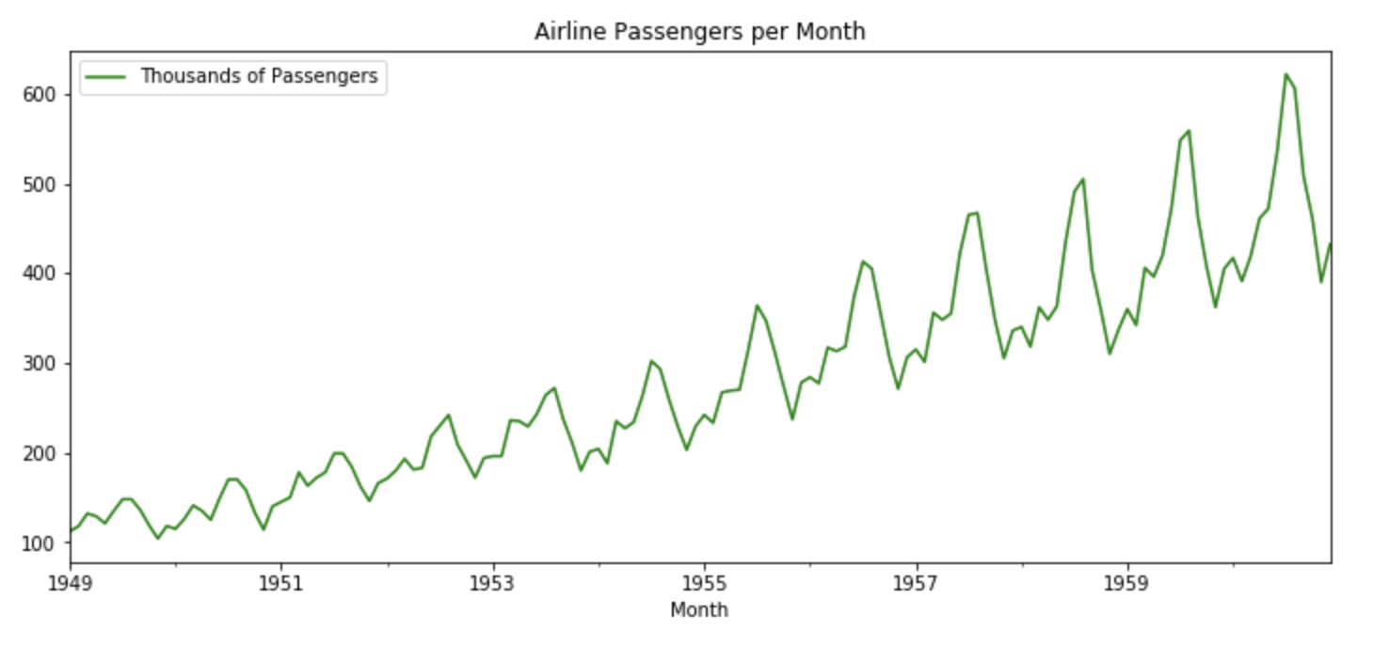

In conclusion, ARIMA models offer a powerful framework for time series analysis and forecasting, enabling researchers, analysts, and decision-makers to extract valuable insights from temporal data. By leveraging the autoregressive, integrated, and moving average components, ARIMA models can capture complex patterns, trends, and dependencies in time series data, making them versatile tools for a wide range of applications in forecasting and predictive analytics. As advancements in data science and machine learning continue to evolve, ARIMA models remain a fundamental technique for understanding and predicting time-dependent phenomena in diverse domains.

1. **DICKEY-FULLER METHOD**

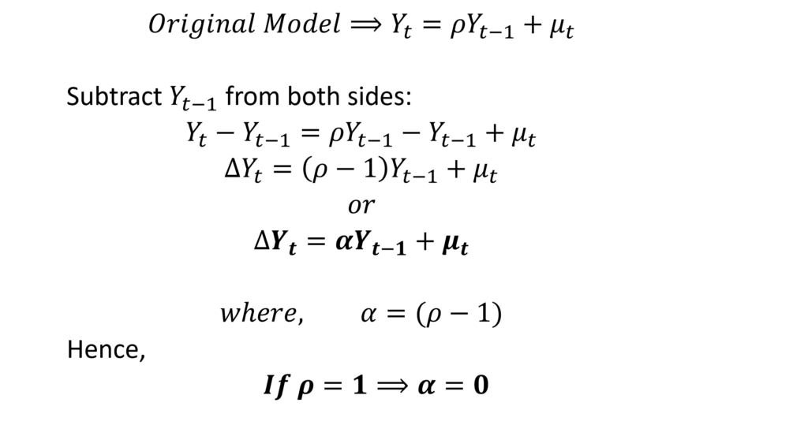

The Dickey-Fuller test, named after economists David Dickey and Wayne Fuller, is a statistical test used to determine whether a time series is stationary or exhibits a unit root, indicating non-stationarity. Stationarity is a key concept in time series analysis, as it implies that the statistical properties of a series, such as mean and variance, remain constant over time. Let's explore the methodology, interpretation, and significance of the Dickey-Fuller test in assessing the stationarity of time series data.

* 1. **Key Concepts** :

**Null Hypothesis (H0**):

- The null hypothesis of the Dickey-Fuller test assumes the presence of a unit root in the time series, indicating non-stationarity.

- A unit root implies that the series has a stochastic trend and does not revert to a constant mean over time.

**Alternative Hypothesis (H1):**

- The alternative hypothesis of the Dickey-Fuller test suggests the absence of a unit root, indicating stationarity.

- Rejection of the null hypothesis in favor of the alternative hypothesis implies that the series is stationary.

**Test Statistic**:

- The Dickey-Fuller test statistic is calculated based on the regression of the differenced series on lagged values of the series.

- The test statistic is compared to critical values from the Dickey-Fuller distribution to determine the stationarity of the series.

* 1. **Methodology:**

**Data Preparation**: The time series data is prepared by checking for trends, seasonality, and other patterns that may indicate non-stationarity.

**Differencing**: If the data is non-stationary, differencing is applied to remove trends and make the series stationary.

**Model Specification**: The Dickey-Fuller test is conducted by regressing the differenced series on lagged values to test for the presence of a unit root.

**Calculation of Test Statistic**: The test statistic is computed, and critical values are used to determine whether to reject the null hypothesis of non-stationarity.

**Interpretation**: If the test statistic is less than the critical value, the null hypothesis is rejected, indicating stationarity. Otherwise, non-stationarity is not rejected.

* 1. **Interpreting the DFT Results**:

- **Rejecting the Null Hypothesis**: If the test statistic is lower than the critical value at a certain significance level, the null hypothesis of non-stationarity is rejected, and the series is considered stationary.

- **Not Rejecting the Null Hypothesis**: If the test statistic is higher than the critical value, the null hypothesis is not rejected, suggesting that the series is non-stationary and exhibits a unit root.

* 1. **Significance of DFT**:

- **Stationarity Assessment**: The Dickey-Fuller test is a fundamental tool for assessing the stationarity of time series data, which is essential for modeling and forecasting.

- **Model Selection**: Stationary time series are easier to model and forecast using techniques such as ARIMA, while non-stationary series may require additional transformations or differencing.

- **Trend Analysis**: By identifying trends and non-stationary behavior in time series data, the Dickey-Fuller test helps analysts understand the underlying patterns and dynamics of the data.

* 1. **Challenges and Considerations**:

- **Sample Size:** The Dickey-Fuller test performance may be influenced by the sample size of the data, with larger samples providing more reliable results.

- **Model Assumptions**: The test assumes that the residuals are independent and identically distributed, which may not always hold true in practice.

**- Model Selection**: Choosing the appropriate lag order and model specifications for the Dickey-Fuller test can impact the test results and interpretation.

The dickey-Fuller test serves as a valuable tool in time series analysis for assessing the stationarity of data and identifying trends and patterns that influence modeling and forecasting. By examining the presence of a unit root in a series, analysts can make informed decisions about data transformations, model selection, and trend analysis, leading to more accurate and reliable insights into the behavior of time-dependent data. The Dickey-Fuller test remains a cornerstone in the toolkit of time series analysts, providing a rigorous framework for evaluating the stationarity of data and uncovering the underlying dynamics of temporal phenomena.

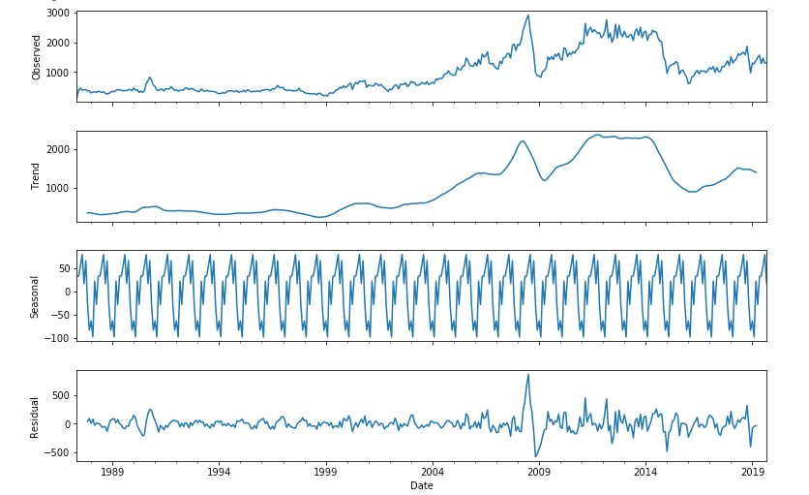

Augmented Dickey-Fuller test

1. **HEAT INDEX**

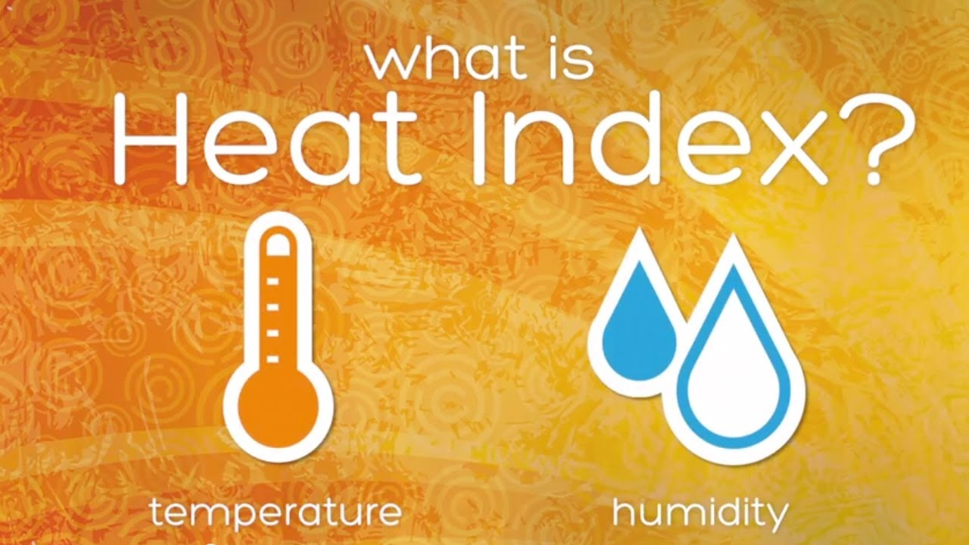

In the realm of meteorology and climatology, the concept of Heat Index holds significant importance as a metric that goes beyond mere temperature readings to provide a more comprehensive understanding of how weather conditions impact human comfort and health. The Heat Index, also known as the apparent temperature, takes into account not only the air temperature but also the relative humidity levels to reflect how hot it feels to the human body. This nuanced measure plays a crucial role in assessing heat-related risks, guiding public health advisories, and informing decision-making in various sectors.

## The Significance of Heat Index

The Heat Index serves as a vital tool for evaluating thermal comfort and heat stress, particularly in environments where high temperatures and humidity levels can pose health hazards. By factoring in the effects of humidity on the body's ability to cool itself through sweating and evaporation, the Heat Index provides a more accurate representation of the perceived temperature experienced by individuals. This metric becomes especially relevant during heatwaves, extreme weather events, and in regions with tropical climates where heat and humidity levels can reach critical levels.

**Calculating the HI :**

The formula for calculating the Heat Index involves complex mathematical relationships between temperature and humidity, reflecting the physiological response of the human body to varying environmental conditions. As humidity levels increase, the body's ability to dissipate heat diminishes, leading to a higher Heat Index reading even when the air temperature remains constant. Meteorologists use specialized equations and algorithms to derive the Heat Index values, taking into account the intricate interplay between temperature, humidity, and heat perception.

**Impacts of High HI Values**

Elevated Heat Index values can have profound implications for human health, well-being, and productivity. Prolonged exposure to high apparent temperatures can increase the risk of heat-related illnesses such as heat exhaustion, heatstroke, and dehydration. Vulnerable populations, including the elderly, children, and individuals with pre-existing health conditions, are particularly susceptible to the adverse effects of extreme heat. Understanding and monitoring the Heat Index is crucial for implementing preventive measures, issuing heat advisories, and mitigating the impacts of heatwaves on public health.

**Meteorological Insights and Weather Forecasting**

In the field of meteorology, the HI serves as a valuable parameter for assessing thermal comfort and heat stress in diverse climatic regions. Meteorologists utilize this metric to enhance weather forecasting models, improve heat-related risk assessments, and provide tailored recommendations to the public during periods of elevated heat Index values. By incorporating the effects of humidity into temperature predictions, meteorological forecasts become more nuanced and reflective of real-world conditions, enabling better preparedness for extreme heat events.

**Urban HI Effect**

The Urban Heat Island effect further amplifies the impact of high temperatures and humidity levels in urban environments, leading to localized increases in the Heat Index. Urban areas characterized by concrete structures, asphalt surfaces, and limited green spaces absorb and retain heat, creating microclimates with elevated temperatures. The combination of the Urban Heat Island effect and high Heat Index values can exacerbate heat-related risks for urban populations, highlighting the importance of urban planning, green infrastructure, and heat mitigation strategies.

Public Health Implications

Health agencies and policymakers rely on Heat Index data to develop heat action plans, implement cooling centers, and disseminate heat safety guidelines to the community. By monitoring Heat Index forecasts and issuing heat advisories, public health officials aim to reduce the incidence of heat-related illnesses, prevent heat-related fatalities, and protect vulnerable populations during periods of extreme heat. Education campaigns on heat safety practices, hydration strategies, and heat illness recognition play a crucial role in raising awareness and promoting resilience to heat stress.

**Climate Change and Heat Index Trends**

The impact of climate change on heat-related risks and Heat Index trends cannot be overlooked. As global temperatures rise and weather patterns become more erratic, the frequency and intensity of heat waves are projected to increase, leading to higher Heat Index values in many regions. Climate models indicate a shift towards more extreme heat events, longer heatwave durations, and heightened heat stress conditions, underscoring the urgency of addressing climate change mitigation and adaptation strategies to safeguard public health and well-being.

**Technological Advancements in Heat Index Prediction**

Advancements in technology, data analytics, and artificial intelligence have opened new avenues for improving Heat Index prediction and monitoring. Deep learning techniques, such as Convolutional Neural Networks (CNNs) and Recurrent Neural Networks (RNNs), offer sophisticated tools for analyzing historical temperature and humidity data, identifying patterns, and generating accurate Heat Index forecasts. By leveraging big data analytics and machine learning algorithms, meteorologists can enhance the precision and reliability of Heat Index predictions, enabling more effective heat risk management strategies.

The Heat Index stands as a critical metric for assessing heat-related risks, evaluating thermal comfort, and guiding public health interventions during periods of elevated temperatures and humidity. By considering the combined effects of temperature and humidity on human perception, the Heat Index provides valuable insights into the real-world impacts of weather conditions on individuals and communities. As we navigate the challenges of a changing climate landscape and increasing heat stress risks, understanding, monitoring, and responding to Heat Index trends becomes essential for promoting resilience, protecting public health, and fostering sustainable urban environments.

A simple long-term average is computed along with this year's values for the year to date period. While this year has seen more than an average amount of hours above values less than 90, the opposite is true for hotter values with 2020 lagging long-term averages. You may wonder how such a combination is possible. We have just seem more warm, but not too hot, days than usual this year. Such weather looks to continue this week.

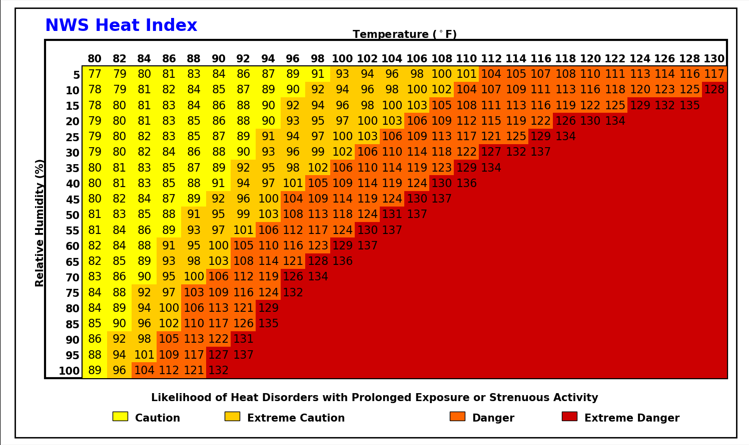

Example:

Unlike Wednesday, storms were not able to save the state from oppressive heat and humidity Thursday afternoon with the entire state reaching at least 100 degrees for heat index. The heat index is a rather interesting expression of how miserable it is outside. It is an estimate that has many caveats and assumptions. There are many different heat index equations out there in the wild. The featured graphic, which you are free to use, presents the [NWS Heat Index equation](https://www.wpc.ncep.noaa.gov/html/heatindex.shtml) values for a given temperature and relative humidity. The chart is capped at about 137F as while heat index values are calculated with larger values, there is a matter of practicality if those large of values are accurate or are even obtainable.

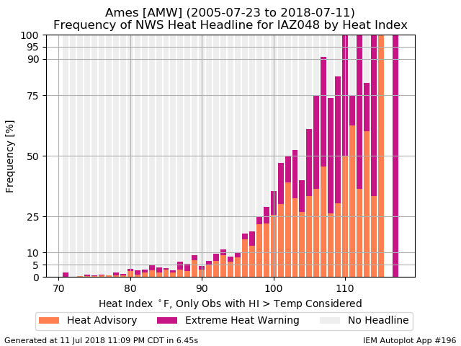

Example:

The heat and humidity weather knobs are again turned well to the right with heat index values expected above 100 degrees for much of the state today. Accordingly, the NWS has a Heat Advisory covering most of the state. The featured chart presents the frequency of the NWS having a heat related headline active for Story County (where the Ames Airport weather station resides). This frequency is based on hourly reports and the major caveat is that having a very hot instantaneous index does not necessarily warrant a headline issuance by the NWS. These headlines typically require a consecutive stretch of hours with high heat indices along with little overnight relief. Heat impacts tend to be cumulative as prolonged exposure to heat decreases resilience.

1. **CODE FOR CHECKING THE CONTINUITY OF THE DATA**

!pip install statsmodels --upgrade

import pandas as pd

import numpy as np

from matplotlib import pyplot

from statsmodels.tsa.ar_model import AutoReg

df = pd.read_csv("C:/Users/faiza/OneDrive/Documents/dfts.csv", index_col=0, parse_dates=True)

X = df.values

print('Shape of data \t', df.shape)

print('Original Dataset:\n',df.head())

print('After extracting only temperature: \n', X)

df.plot()

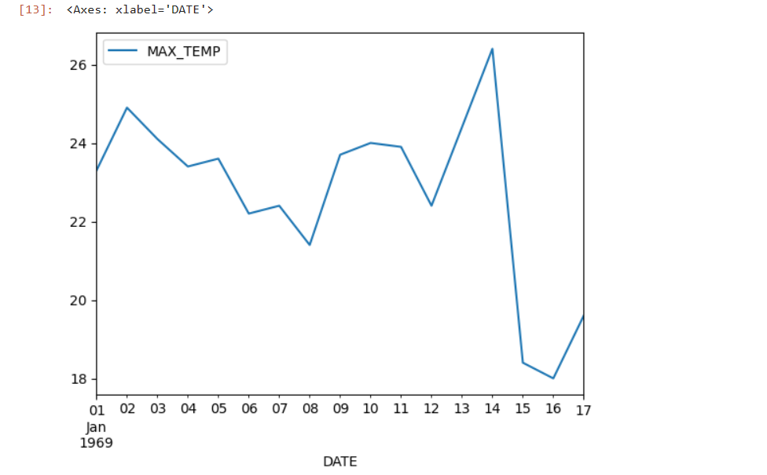

from statsmodels.tsa.stattools import adfuller

dftest= adfuller(df['MAX_TEMP'],autolag='AIC')

print("1.ADF:",dftest[0])

print("2. P_Value:", dftest[1])

print("3.Number of lags:",dftest[2])

print("4.Num of observations used for ADF Regression and Critical Values Calculation:",dftest[3])

print("5. Critical Values:")

for key,val in dftest[4].items():

print("\t",key,":",val)

from statsmodels.graphics.tsaplots import plot_pacf,plot_acf

pacf = plot_pacf(df['MAX_TEMP'],lags=3)

acf = plot_acf(df['MAX_TEMP'],lags=3)

train =X[:len(X)-7]

test =X[len(X)-7:]

model= AutoReg(train, lags=4).fit()

print(model.summary())

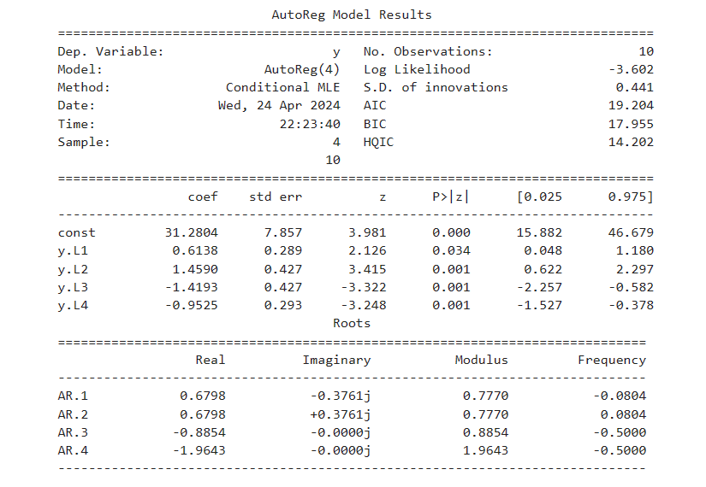

# Predicting future temperature

print(len(train))

10

pred = model.predict(start=len(train),end=len(X)-1,dynamic= False)

from matplotlib import pyplot

pyplot.plot(pred)

pyplot.plot(test,color='red')

print(pred)

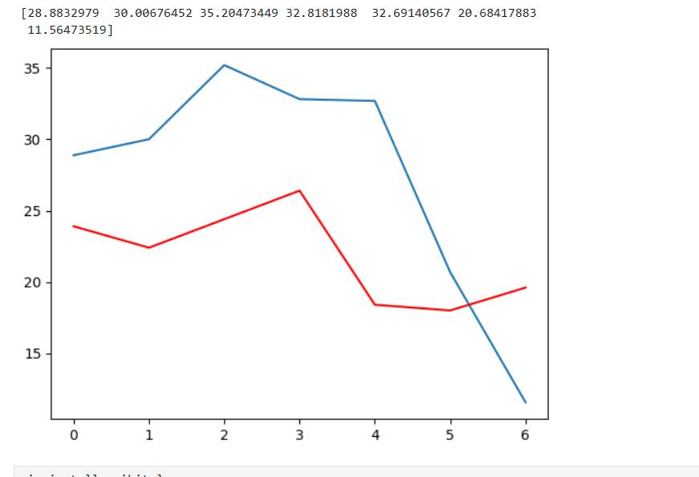

pip install scikit-learn

from math import sqrt

from sklearn.metrics import mean_squared_error

rmse= sqrt(mean_squared_error(test,pred))

print(rmse)

8.591077267125446

pred_future= model.predict(start=len(X)+1, end= len(X)+7,dynamic= False)

print("The future prediction for the next week")

print(pred_future)

print('Number of Predictions made: \t', len(pred_future))

1. **LSTM MODEL**

**(Long Short-Term Memory)**

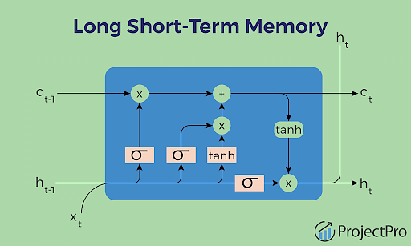

LSTM models are a type of recurrent neural network (RNN) architecture designed to capture long-term dependencies in sequential data. LSTMs address the vanishing gradient problem of traditional RNNs by introducing specialized memory cells that can retain information over extended time periods. Let's explore the components, functionality, and applications of LSTM models in deep learning and time series analysis.

* 1. **Key Components** :

**Cell State**:

- The cell state in an LSTM model serves as a conveyor belt that carries information across time steps.

- The cell state can be modified through a series of operations, allowing the model to retain or discard information as needed.

**Forget Gate**:

- The forget gate in an LSTM controls the flow of information from the previous cell state.

- By using a sigmoid activation function, the forget gate decides which information to keep or forget based on the current input.

**Input Gate**:

- The input gate in an LSTM determines which new information to store in the cell state.

- It consists of a sigmoid activation function to regulate the input and a tanh activation function to create a new candidate value.

**Output Gate**:

- The output gate in an LSTM decides what information to output based on the current cell state.

- It filters the cell state through a sigmoid function and applies the tanh function to control the output.

* 1. **Functionality** :

**Long-Term Dependency Handling**: LSTMs excel at capturing long-term dependencies in sequential data, making them suitable for tasks that require memory of past events.

**Gradient Flow Control:** By introducing specialized gates and memory cells, LSTMs mitigate the vanishing gradient problem, allowing for more effective training on long sequences.

**Sequence Prediction:** LSTMs are commonly used for sequence prediction tasks such as time series forecasting, natural language processing, and speech recognition.

* 1. **Applications of LSTM Models**:

**Time Series Forecasting**:

- LSTM models are widely used in time series forecasting to predict future values based on historical data patterns.

**Natural Language Processing (NLP):**

- LSTMs are employed in NLP tasks such as language translation, sentiment analysis, and text generation due to their ability to capture sequential dependencies in text data.

**Speech Recognition**:

- LSTMs play a crucial role in speech recognition systems by processing audio data and predicting phonetic sequences.

**Healthcare Analytics**:

- In healthcare analytics, LSTM models are utilized for predicting patient outcomes, disease progression, and medical diagnosis based on sequential patient data.

**Financial Modeling:**

- LSTMs are applied in financial modeling for predicting stock prices, market trends, and investment strategies using historical market data.

* 1. **Advantages** :

- **Long-Term Memory**: LSTMs can retain information over extended time periods, making them effective for capturing complex patterns in sequential data.

**-Flexibility**: LSTMs can handle inputs of varying lengths and adapt to different temporal structures, providing versatility in modeling time-dependent data.

- **State-of-the-Art Performance**: LSTMs have demonstrated state-of-the-art performance in various tasks such as language modeling, speech recognition, and time series forecasting.

* 1. **Challenges and Considerations**:

- **Model Complexity**: Designing and training LSTM models can be computationally intensive, requiring sufficient data and computational resources.

- **Overfitting:** LSTMs are prone to overfitting, especially with small datasets, necessitating regularization techniques and hyperparameter tuning.

- **Interpretability:** Understanding how LSTMs make predictions and interpreting the learned representations can be challenging due to the complex architecture of the model.

LSTM models represent a powerful tool in deep learning for capturing long-term dependencies in sequential data and making accurate predictions in tasks such as time series forecasting, natural language processing, and speech recognition. By leveraging specialized memory cells and gating mechanisms, LSTMs overcome the limitations of traditional RNNs and excel in modeling complex temporal relationships. As advancements in deep learning continue to evolve, LSTM models remain at the forefront of research and innovation, driving progress in diverse domains that rely on sequential data analysis and prediction.

* 1. **Equations LSTM:**

The Long Short-Term Memory model is a type of recurrent neural network (RNN) architecture that is designed to capture long-term dependencies in sequential data. LSTMs are equipped with specialized memory cells and gating mechanisms that enable them to retain and update information over multiple time steps. The key equations that govern the operation of an LSTM model include the calculations for the forget gate, input gate, cell state, and output gate. Let's delve into the mathematical formulations of these components:

**Forget Gate**:

The forget gate in an LSTM model controls the flow of information from the previous cell state. It determines which information to retain and which to discard based on the current input and the previous cell state. The calculation of the forget gate at time step \( t \) is given by:

\[ f_t = \sigma(W_f \cdot [h_{t-1}, x_t] + b_f) \]

Where:

- \( f_t \) is the forget gate at time step \( t \).

- \( \sigma \) is the sigmoid activation function.

- \( W_f \) is the weight matrix for the forget gate.

- \( h_{t-1} \) is the previous hidden state.

- \( x_t \) is the input at time step \( t \).

- \( b_f \) is the bias term for the forget gate.

**Input Gate:**

The input gate in an LSTM model determines which new information to store in the cell state. It consists of two components: the input gate and the candidate value that will be added to the cell state. The calculation of the input gate and the candidate value at time step \( t \) is given by:

\[ i_t = \sigma(W_i \cdot [h_{t-1}, x_t] + b_i) \]

\[ \tilde{C}_t = \tanh(W_C \cdot [h_{t-1}, x_t] + b_C) \]

Where:

- \( i_t \) is the input gate at time step \( t \).

- \( \tilde{C}_t \) is the candidate value.

- \( W_i \) and \( W_C \) are the weight matrices for the input gate and candidate value, respectively.

- \( b_i \) and \( b_C \) are the bias terms for the input gate and candidate value.

**Update the Cell State:**

The next step involves updating the cell state by combining the information retained from the previous cell state (after applying the forget gate) and the new information to be added (after applying the input gate). The updated cell state at time step \( t \) is calculated as:

\[ C_t = f_t \cdot C_{t-1} + i_t \cdot \tilde{C}_t \]

Where:

- \( C_t \) is the updated cell state at time step \( t \).

**Output Gate**:

The output gate in an LSTM model determines what information to output based on the updated cell state. It filters the cell state through a sigmoid function and applies the tanh function to control the output. The calculation of the output gate and the hidden state at time step \( t \) is given by:

\[ o_t = \sigma(W_o \cdot [h_{t-1}, x_t] + b_o) \]

\[ h_t = o_t \cdot \tanh(C_t) \]

Where:

- \( o_t \) is the output gate at time step \( t \).

- \( h_t \) is the hidden state at time step \( t \).

- \( W_o \) is the weight matrix for the output gate.

- \( b_o \) is the bias term for the output gate.

These equations represent the core computations of an LSTM model, encompassing the forget gate, input gate, cell state update, and output gate. By iteratively applying these calculations over multiple time steps, LSTMs can effectively capture long-term dependencies in sequential data and make accurate predictions in various tasks such as time series forecasting, natural language processing, and speech recognition.

1. **CODE FOR PREDICTING HEAT INDEX**

import pandas as pd

import numpy as np

import matplotlib.pyplot as plt

import seaborn as sns

from sklearn.model_selection import train_test_split

from tensorflow.keras.models import Sequential

from tensorflow.keras.layers import LSTM, Dense

import warnings

warnings.filterwarnings(action="ignore")

pip install seaborn

# Load and preprocess the dataset

filename = "resultant_heat_index_data.csv"

data = pd.read_csv('C:/Users/faiza/OneDrive/Desktop/IMD/resultant_heat_index_data.csv', index_col=0, parse_dates=True)

data['DBT'] = pd.to_numeric(data['DBT'], errors='coerce')

data['DPT'] = pd.to_numeric(data['DPT'], errors='coerce')

data['RH'] = pd.to_numeric(data['RH'], errors='coerce')

data['Heat Index'] = pd.to_numeric(data['Heat Index'], errors='coerce')

# Drop rows with missing values

data.dropna(inplace=True)

# Scale the data (optional but recommended for neural networks)

from sklearn.preprocessing import MinMaxScaler

scaler = MinMaxScaler()

scaled_data = scaler.fit_transform(data[['DBT', 'DPT', 'RH', 'Heat Index']])

# Define window size for creating sequences

window_size = 12 # Number of time steps to look back

# Create sequences of input features and target values

sequences = []

targets = []

for i in range(window_size, len(scaled_data)):

sequences.append(scaled_data[i-window_size:i, :3]) # Input features (DBT, DPT, RH)

targets.append(scaled_data[i, 3]) # Target value (Heat Index)

# Convert sequences and targets to numpy arrays

X = np.array(sequences)

y = np.array(targets)

# Print the shape of the input data

print("Input data shape:", X.shape)

print("Target data shape:", y.shape)

Input data shape: (49398, 12, 3)

Target data shape: (49398,)

# Split the data into training and testing sets

X_train, X_test, y_train, y_test = train_test_split(X, y, test_size=0.2, random_state=42)

# Print the shapes of the training and testing sets

print("X_train shape:", X_train.shape)

print("y_train shape:", y_train.shape)

print("X_test shape:", X_test.shape)

print("y_test shape:", y_test.shape)

X_train shape: (39518, 12, 3)

y_train shape: (39518,)

X_test shape: (9880, 12, 3)

y_test shape: (9880,)

# Define the LSTM model architecture

model = Sequential()

model.add(LSTM(64, input_shape=(X_train.shape[1], X_train.shape[2])))

model.add(Dense(1)) # Output layer (1 neuron for regression task)

# Compile the model

model.compile(optimizer='adam', loss='mse')

# Train the model

history = model.fit(X_train, y_train, epochs=50, batch_size=32, validation_split=0.1)

# Evaluate the model on the test set

loss = model.evaluate(X_test, y_test)

print("Test Loss:", loss)

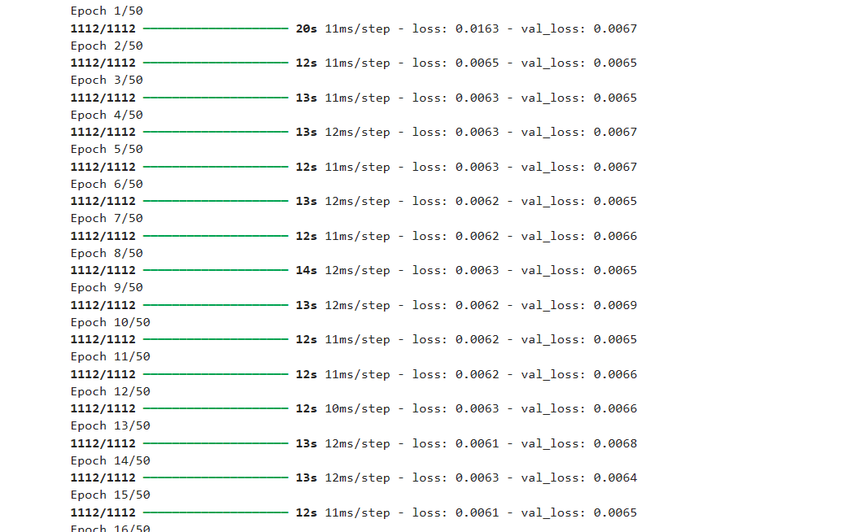

# Plot training history

plt.plot(history.history['loss'], label='Train Loss')

plt.plot(history.history['val_loss'], label='Val Loss')

plt.xlabel('Epoch')

plt.ylabel('Loss (MSE)')

plt.title('Training History')

plt.legend()

plt.show()

# Make predictions on the test set

y_pred = model.predict(X_test)

# Inverse transform the scaled predictions and actual values

y_pred = scaler.inverse_transform(np.concatenate((X_test[:, -1, :3], y_pred.reshape(-1, 1)), axis=1))[:, -1]

y_test_actual = scaler.inverse_transform(np.concatenate((X_test[:, -1, :3], y_test.reshape(-1, 1)), axis=1))[:, -1]

# Calculate evaluation metrics (e.g., RMSE)

from sklearn.metrics import mean_squared_error, mean_absolute_error

rmse = np.sqrt(mean_squared_error(y_test_actual, y_pred))

mae = mean_absolute_error(y_test_actual, y_pred)

print("Test RMSE:", rmse)

print("Test MAE:", mae)

# Plot Heat Index Over Time

plt.figure(figsize=(12, 6))

plt.plot(y_test_actual, label='Actual Heat Index', color='blue', alpha=0.7)

plt.plot(y_pred, label='Predicted Heat Index', color='red', alpha=0.7)

plt.title('Heat Index Over Time')

plt.xlabel('Index')

plt.ylabel('Heat Index')

plt.legend()

plt.grid(True)

plt.show()

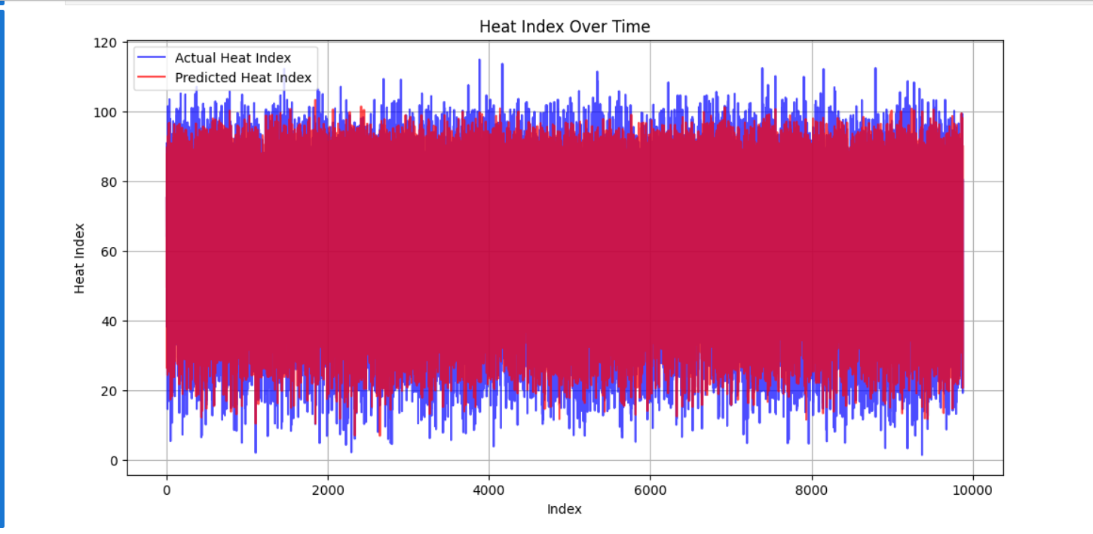

# Plot Heat Index vs. Dry Bulb Temperature

plt.figure(figsize=(10, 6))

sns.scatterplot(x=X_test[:, -1, 0], y=y_test_actual, label='Actual Heat Index', color='blue', alpha=0.7)

plt.show()

plt.figure(figsize=(10, 6))

sns.scatterplot(x=X_test[:, -1, 0], y=y_pred, label='Predicted Heat Index', color='red', alpha=0.7)

# sns.scatterplot(x=X_test[:, -1, 0], y=y_test_actual, label='Actual Heat Index', color='blue', alpha=0.7)

plt.title('Heat Index vs. Dry Bulb Temperature')

plt.xlabel('Dry Bulb Temperature (°C)')

plt.ylabel('Heat Index')

plt.legend()

plt.grid(True)

plt.show()

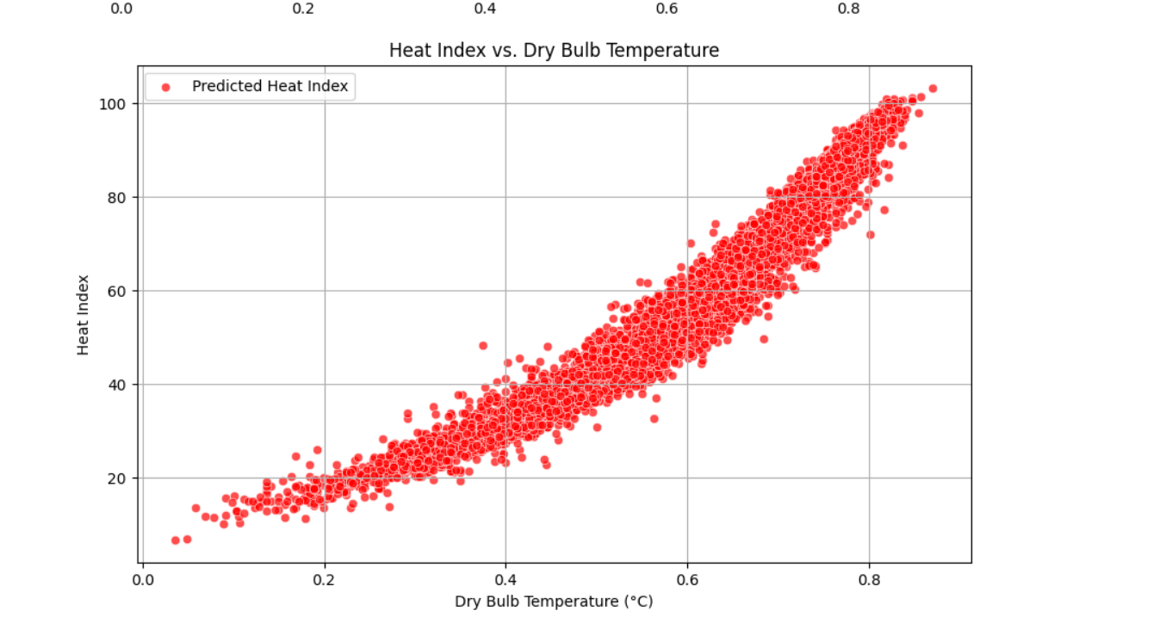

# Plot Distribution of Heat Index

plt.figure(figsize=(10, 6))

sns.histplot(y_pred, bins=20, kde=True, color='red', alpha=0.7, label='Predicted Heat Index')

sns.histplot(y_test_actual, bins=20, kde=True, color='blue', alpha=0.7, label='Actual Heat Index')

plt.title('Distribution of Heat Index')

plt.xlabel('Heat Index')

plt.ylabel('Frequency')

plt.legend()

plt.grid(True)

plt.show()

# Extract DBT, RH, and predicted Heat Index from X_test and y_pred

dbt = X_test[:, -1, 0] # Dry Bulb Temperature

rh = X_test[:, -1, 2] # Relative Humidity

heat_index_pred = y_pred # Predicted Heat Index

# Create a DataFrame with DBT, RH, and predicted Heat Index

heatmap_data = pd.DataFrame({'DBT': dbt, 'RH': rh, 'Predicted Heat Index': heat_index_pred})

# Optionally, you can round the values for better visualization

heatmap_data['DBT'] = np.round(heatmap_data['DBT'], decimals=1)

heatmap_data['RH'] = np.round(heatmap_data['RH'], decimals=1)

# Plot Heatmap of Heat Index by Dry Bulb Temperature and Relative Humidity

plt.figure(figsize=(12, 8))

heatmap = heatmap_data.pivot_table(values='Predicted Heat Index', index='DBT', columns='RH', aggfunc='mean')

sns.heatmap(heatmap, cmap='YlOrRd', annot=True, fmt='.1f', linewidths=.5)

plt.title('Heat Index by Dry Bulb Temperature and Relative Humidity')

plt.xlabel('Relative Humidity (%)')

plt.ylabel('Dry Bulb Temperature (°C)')

plt.show()

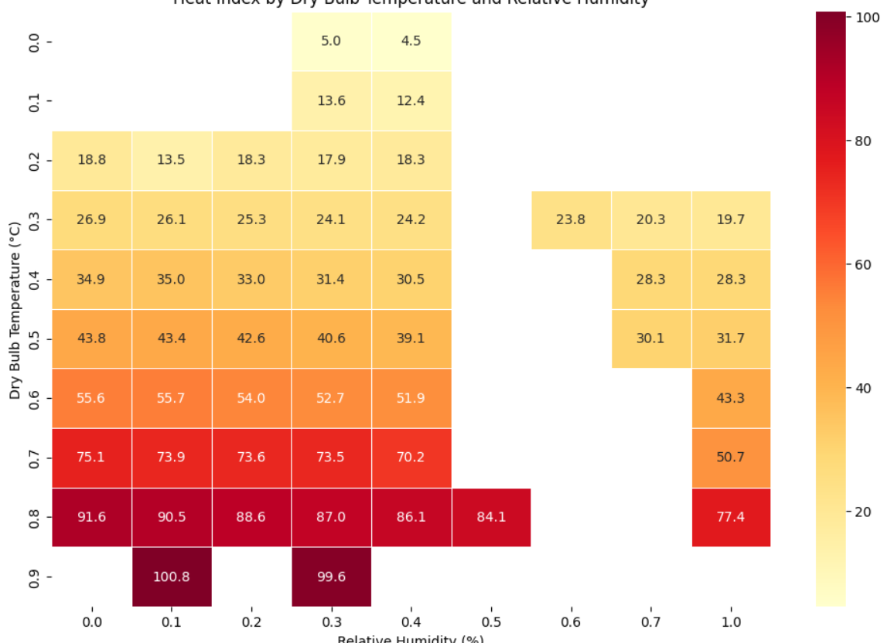

1. **KEY POINTS**

**Loading and Preprocessing**:

Load the dataset and ensure all relevant columns (DBT, DPT, RH, Heat Index) are numeric.

Drop rows with missing values.

Normalize the data using MinMaxScaler for better performance with the LSTM model.

**Sequence Creation**:

Define a window size to create sequences for time series prediction.

Create sequences of input features and corresponding target values.

**Data Splitting:**

Split the data into training and testing sets using train_test_split.

**Model Definition and Training:**

Define a simple LSTM model using Sequential, LSTM, and Dense layers.

Compile and train the model, including a validation split to monitor training.

**Evaluation and Visualization**:

Evaluate the model on the test set and calculate performance metrics such as RMSE and MAE.

Visualize the training history, actual vs. predicted heat index over time, scatter plots of heat index vs. dry bulb temperature, and the distribution of the heat index.

Create a heatmap of predicted heat index values by dry bulb temperature and relative humidity.

This structured approach ensures a clear flow from data loading and preprocessing to model training and evaluation, including comprehensive visualization of the results.

1. **UNDERSTANDING EACH LINE OF CODE**

**Importing Libraries**:

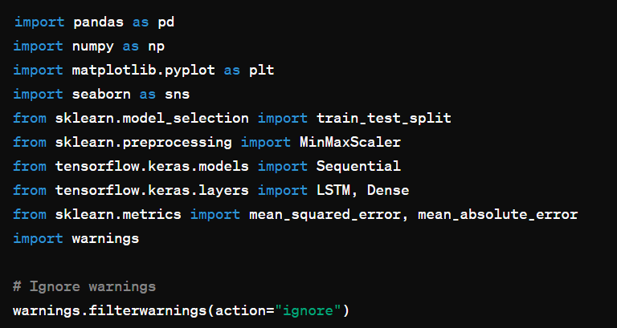

* import pandas as pd: Import the pandas library for data manipulation and analysis.
* import numpy as np: Import the NumPy library for numerical operations.
* import matplotlib.pyplot as plt: Import Matplotlib for plotting and visualization.
* import seaborn as sns: Import Seaborn for statistical data visualization.
* from sklearn.model_selection import train_test_split: Import function to split data into training and testing sets.
* from sklearn.preprocessing import MinMaxScaler: Import MinMaxScaler to normalize data.
* from tensorflow.keras.models import Sequential: Import Sequential model from Keras to build neural networks.
* from tensorflow.keras.layers import LSTM, Dense: Import LSTM and Dense layers for constructing the neural network.
* from sklearn.metrics import mean_squared_error, mean_absolute_error: Import functions to compute evaluation metrics.
* import warnings: Import the warnings library to control warning messages.
* warnings.filterwarnings(action="ignore"): Ignore warnings for cleaner output.

**Loading and Preprocessing the dataset**

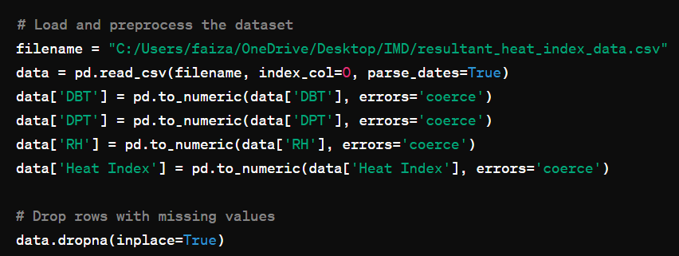

* filename = "C:/Users/faiza/OneDrive/Desktop/IMD/resultant_heat_index_data.csv": Define the path to the dataset.
* data = pd.read_csv(filename, index_col=0, parse_dates=True): Load the dataset into a DataFrame, using the first column as the index and parsing date columns.
* data['DBT'] = pd.to_numeric(data['DBT'], errors='coerce'): Convert the 'DBT' column to numeric, setting invalid parsing to NaN.
* data['DPT'] = pd.to_numeric(data['DPT'], errors='coerce'): Convert the 'DPT' column to numeric.
* data['RH'] = pd.to_numeric(data['RH'], errors='coerce'): Convert the 'RH' column to numeric.
* data['Heat Index'] = pd.to_numeric(data['Heat Index'], errors='coerce'): Convert the 'Heat Index' column to numeric.
* data.dropna(inplace=True): Remove rows with NaN values from the dataset.

**Scaling the data:**

scaler = MinMaxScaler(): Instantiate the MinMaxScaler for normalization.

scaled_data = scaler.fit_transform(data[['DBT', 'DPT', 'RH', 'Heat Index']]): Scale the specified columns to the range [0, 1].

**Creating Sequences for LSTM models**:

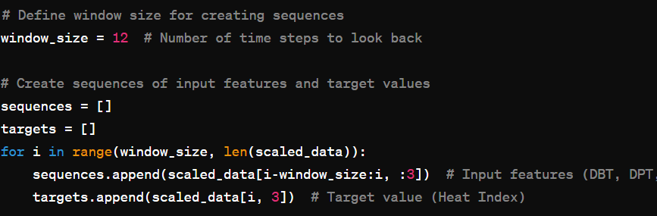

* window_size = 12: Define the number of previous time steps to use for each prediction.
* sequences = []: Initialize an empty list to store sequences of input features.
* targets = []: Initialize an empty list to store target values.
* for i in range(window_size, len(scaled_data)):: Iterate over the dataset, starting from window_size to the end.
* sequences.append(scaled_data[i-window_size:i, :3]): Append the sequence of the previous window_size steps for features 'DBT', 'DPT', and 'RH'.
* targets.append(scaled_data[i, 3]): Append the target value (Heat Index) corresponding to the current step.

**Converting Sequences and Target to Numpy Arrays**:

* X = np.array(sequences): Convert the list of sequences to a numpy array.
* y = np.array(targets): Convert the list of targets to a numpy array.
* print("Input data shape:", X.shape): Print the shape of the input data array.
* print("Target data shape:", y.shape): Print the shape of the target data array.

**Splitting the data into Training and Testing Sets:**

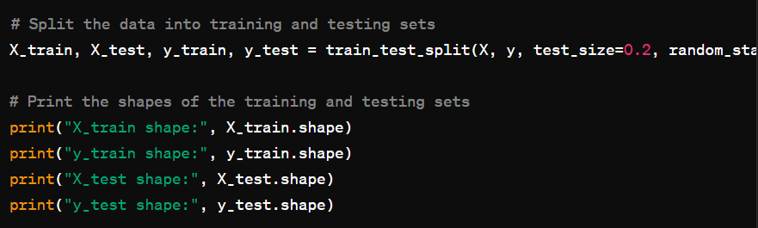

* X_train, X_test, y_train, y_test = train_test_split(X, y, test_size=0.2, random_state=42): Split the data into training (80%) and testing (20%) sets, with a fixed random state for reproducibility.
* print("X_train shape:", X_train.shape): Print the shape of the training input data.
* print("y_train shape:", y_train.shape): Print the shape of the training target data.
* print("X_test shape:", X_test.shape): Print the shape of the testing input data.
* print("y_test shape:", y_test.shape): Print the shape of the testing target data.

**Defining and training the LSTM model**:

* model = Sequential(): Initialize a sequential model.
* model.add(LSTM(64, input_shape=(X_train.shape[1], X_train.shape[2]))): Add an LSTM layer with 64 units, specifying the shape of the input data.
* model.add(Dense(1)): Add a dense layer with a single unit for the output.
* model.compile(optimizer='adam', loss='mse'): Compile the model using the Adam optimizer and mean squared error loss function.
* history = model.fit(X_train, y_train, epochs=50, batch_size=32, validation_split=0.1): Train the model for 50 epochs with a batch size of 32, using 10% of the training data for validation.

**Evaluating the model**:

* loss = model.evaluate(X_test, y_test): Evaluate the model on the test data and get the loss value.
* print("Test Loss:", loss): Print the test loss.

**Plotting Training History**:

* plt.plot(history.history['loss'], label='Train Loss'): Plot the training loss over epochs.
* plt.plot(history.history['val_loss'], label='Val Loss'): Plot the validation loss over epochs.
* **`plt.xlabel('Epoch

1. **CONCLUSION**

In the realm of meteorology and climate science, the accurate prediction of the Heat Index for a large region plays a crucial role in assessing heat-related risks, protecting public health, and informing decision-making in various sectors. By leveraging deep learning techniques, such as Convolutional Neural Networks (CNNs), Recurrent Neural Networks (RNNs), and Long Short-Term Memory (LSTM) models, researchers can enhance the precision and reliability of Heat Index predictions, enabling proactive measures to be taken in response to extreme heat events.

The implementation of deep learning models for Heat Index prediction offers several key advantages, including:

**Feature Extraction:**

Deep learning models excel at extracting intricate patterns and relationships from meteorological data, allowing for a more comprehensive analysis of temperature and humidity dynamics in a large region.

Temporal Dependency Handling:

RNNs and LSTM models are well-suited for capturing long-term dependencies in time series data, enabling the modeling of complex temporal relationships in Heat Index predictions.

**Spatial Analysis:**

CNNs are effective in analyzing spatial data, such as satellite images and weather radar data, to enhance the spatial resolution and accuracy of Heat Index forecasts for a large geographic area.

**Scalability:**

Deep learning models can scale to process vast amounts of meteorological data efficiently, making them suitable for analyzing Heat Index variations across a large region with diverse climatic conditions.

By integrating deep learning techniques into the prediction of the Heat Index for a large region, researchers can improve the understanding of heat-related phenomena, enhance early warning systems for extreme heat events, and support the development of targeted interventions to mitigate the impacts of heat stress on populations. Furthermore, the application of deep learning in meteorology underscores the potential for innovation and advancement in climate science, paving the way for more accurate and actionable insights into the complex interactions between temperature, humidity, and human comfort.

As we continue to explore the intersection of deep learning and meteorology, the integration of advanced modeling approaches and data-driven methodologies holds promise for revolutionizing Heat Index prediction and climate analysis on a regional and global scale. By harnessing the power of deep learning techniques, researchers can unlock new possibilities for enhancing heat risk management, promoting resilience to extreme weather events, and safeguarding the well-being of communities in the face of a changing climate landscape.

**REFERENCES**